Name: ______________________________________ Date: ________________________

Plate Tectonics

Vocabulary: asthenosphere, collision zone, convergent boundary, crust, divergent boundary, earthquake, lithosphere, mantle, plate, plate tectonics, subduction zone, transform boundary, volcano

Prior Knowledge Questions (Do these BEFORE using the Gizmo.)

- Volcanoes are openings in Earth’s crust where lava, gas, and ash can erupt. Google Search: Where are active volcanoes located? Record answer below.
Answer:

- An earthquake is a violent shaking of Earth’s surface. Google Search: Where are earthquakes common?
Answer:

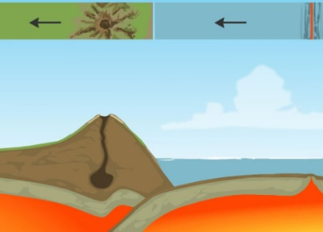
Gizmo Warm-up
Volcanoes, earthquakes, mountains, and other features of Earth’s surface owe their origin to the movements of plates: enormous, slowly-moving sections of Earth’s crust. At plate boundaries, plates collide, move apart, move under or over each other, or slide past one another. The theory of plate tectonics describes how the plates move, interact, and change the physical landscape.

The Plate Tectonics Gizmo shows a cross-section, or side view, of Earth. (Not to scale.) Above the cross section is a bird’s-eye view of the same location.
- Turn on Show labels. What are the layers of Earth that you can see?
Answer:

The lithosphere is a layer of rigid rock that consists of the crust and the upper part of Earth’s mantle. The asthenosphere is a layer of the mantle that can deform like plastic.
- Turn on Boundary name and click on each boundary (located at top of Gizmo [Boundary A, Boundary B, Boundary C, Boundary D]). What four boundaries do you see?
Answer:

Activity A:  Sliding plates | Get the Gizmo ready:  - Select BOUNDARY A. | 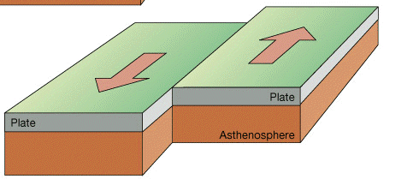 | 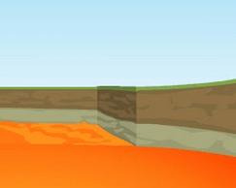

Question: What happens when plates slide past one another?

- Observe: Boundary A is a transform boundary. The arrows below the BOUNDARY A label will move the plates. Click the left arrow twice to see how the plates move.

How would you describe the motion of plates in a transform boundary?
Answer:

- Locate: Using the Draw tool, highlight where transform plate boundaries are located on the map, below.
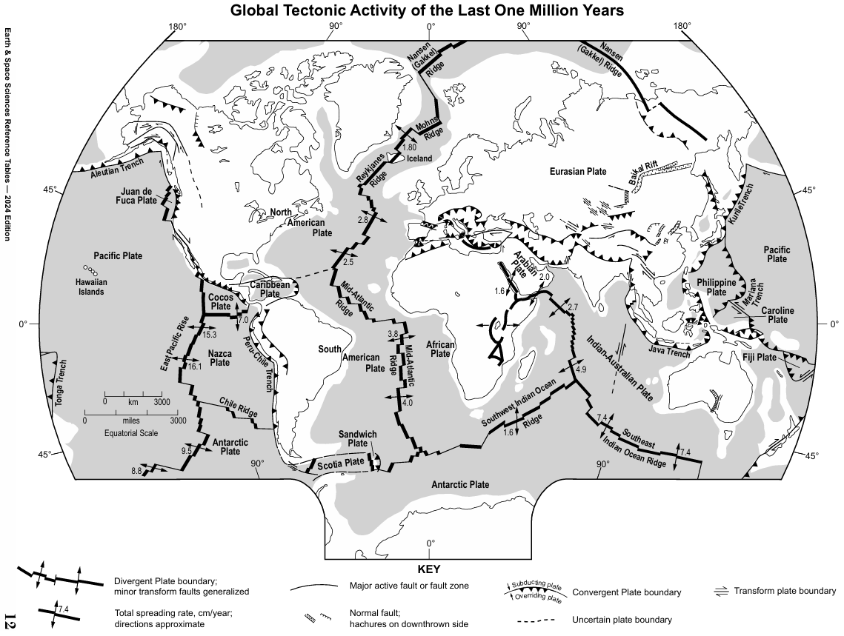

Activity B:  Colliding continents | Get the Gizmo ready:  - Turn off Boundary name and Show location.  - Select BOUNDARY B. | 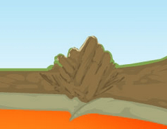

Question: What happens when two continents collide?

- Observe: Boundary B is an example of a convergent boundary, where two plates are moving toward one another. When the two converging plates both contain continental crust, it is called a collision zone. Click the left arrow four times to see how the plates move.

How would you describe the motion of plates in a collision zone?
Answer:

- Locate: Using the Draw tool, highlight where collision zones are located on the map, below. (**Remember: these are located ONLY on land. Double check your work by turning on Show location in the Gizmo**)


Activity C:  Oceanic crust meets continental crust | Get the Gizmo ready:  - Turn off Boundary name and Show location.  - Select BOUNDARY C. | 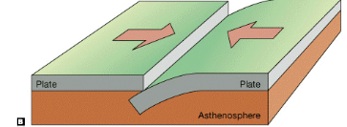 | 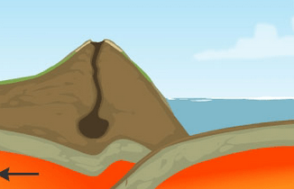

Question: What happens when ocean crust collides with continental crust?

- Observe: Boundary C is another type of convergent boundary called a subduction zone. Click the left arrow four times to see how the plates move.

How would you describe the motion of plates in a subduction zone?
Answer:

- Locate: Using the Draw tool, highlight where subduction zones are located on the map, below. (**Double check your work by turning on Show location in the Gizmo**)


Activity D:  Spreading plates | Get the Gizmo ready:  - Turn off Boundary name and Show location.  - Select BOUNDARY D. | 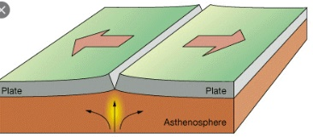 | 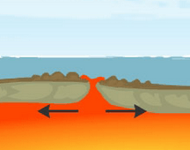

Question: How is new crust formed?

- Observe: Boundary D is a divergent boundary. Click the right arrow four times to see how the plates move.

How would you describe the motion of plates in a divergent boundary?
Answer:

- Locate: Using the Draw tool, highlight where divergent plate boundaries are located on the map, below.


NYS Regents Questions on Next Pages
